End-Term Project Report on
Gestured Controlled Robot using Raspberry Pi
Submitted by

Shreya Srestha Bhattamisra (2341002175)
Tanisha Patro (2341016295)
Payal Priya Panigrahi (2341016142)
Abhipsa Mishra (2341013155)
Ipsita Dash(2341004167)
Payal Das

B. Tech. (CSE(IOT) 5th Semester (Section–23412B1)



DEPARTMENT OFCOMPUTER SCIENCE AND ENGINEERING
Institute of Technical Education and Research

SIKSHA ‘O’ ANUSANDHAN
DEEMED TO BE UNIVERSITY

Bhubaneswar, Odisha, India.
(December 2025)

Abstract
This project presents the design and implementation of a Gesture Controlled Robot using Raspberry Pi, aimed at providing an intuitive and contactless method for controlling robotic movement. The system uses a camera-based hand gesture recognition approach, where hand gestures are captured in real time and processed using OpenCV image processing techniques. The Raspberry Pi acts as the central processing unit, interpreting the recognized gestures and converting them into appropriate control signals for the motor driver, which in turn drives the robot’s DC motors.
The proposed system eliminates the need for conventional input devices such as joysticks or remote controllers, thereby enhancing human–robot interaction through natural hand movements. The robot is capable of performing basic navigational movements such as forward, slow and stop based on predefined gestures. By leveraging the computational capabilities of the Raspberry Pi and the flexibility of Python programming, the system achieves real-time responsiveness with minimal hardware complexity.
This project demonstrates an effective integration of computer vision, embedded systems, and IoT concepts to develop a low-cost and scalable robotic solution. The gesture controlled robot has potential applications in hazardous environments, assistive technologies, automation systems, and educational platforms, where touch-free and intuitive control is essential.

Contents

Abstract i
Contents ii
Chapter 01: Introduction 1
1.1. Introduction 1
1.2. Background 1
1.3. Project Objectives 1
1.4. Scope 1
1.5. Project Management 1
1.6. Overview and Benefits 2
1.7. Organization of the Report 2
Chapter 02: Background Review & Survey 3
2.1. Related Works 3
Chapter 03: Theoretical Aspects 4
3.1. Project Aspects 4
3.1.1. Features of IoT 4
3.1.2. Advantages of IoT 4
3.1.3. Disadvantages of IoT 4
3.1.4. Application areas of IoT 4
3.2. IOT Technologies and Protocols // related to project 4
3.3. Project Layout 5
3.3.1. Brief Description 5
3.4. Background Theory 5
Chapter 04: Hardware Requirements 6
4.1. Raspberry Pi 4 / Raspberry Pi 5 6
4.1.1. Features 6
4.1.2. Pin Configuration 6
4.2. Camera 6
4.3. Sensors 6
4.3.1. …………………………………………………………………………………6
4.4. Motor Drivers 6
4.5. Motors 6
4.6. Working of the proposed system 6
4.6.1. Block Diagram of the system 6
4.6.2. Circuit Diagram 6
4.6.3. Working 6
4.6.4. Components Required 7
Chapter 05: Software Requirements 8
5.1. Thonny IDE/ VS code/ Python 8
5.2. Logic and Flowchart 8
Chapter 06: Project development & Testing Aspects 9
6.1. Hardware Integration 9
6.2. Software Set-up 9
6.3. Testing 9
6.4. Results and Discussions 9
Chapter 07: Conclusion & Future Scope 10
7.1. Conclusion 10
7.2. Limitations 10
7.3. Further Enhancement and Future Scope 10
References 11
Appendix 01 12
A01.1. Code Listing 12
A01.2. Main Code 12
A01.3. Libraries 12
Appendix 02 13
A02.1. Project Proposal Form 13
A02.2. Project Management 13
A02.3. Bill of Material 13
Appendix 03 15
A03.1. Data Sheets 15

Chapter 01: Introduction

Introduction
The rapid growth of embedded systems, robotics, computer vision, and Internet of Things (IoT) technologies has transformed the way humans interact with machines. Traditional human–machine interaction methods such as switches, keyboards, joysticks, and remote controllers require physical contact and manual operation, which may not always be convenient, efficient, or safe. To overcome these limitations, gesture-based control systems have emerged as a natural, intuitive, and contactless mode of interaction.
A gesture controlled robot is a robotic system that interprets human hand gestures as control commands and executes corresponding movements. Hand gestures are a natural form of communication used by humans in everyday life, and utilizing them for robot control enhances usability and interaction efficiency. Gesture-based systems reduce dependency on mechanical input devices and provide a more immersive and user-friendly experience.
In this project, a Gesture Controlled Robot using Raspberry Pi is designed and implemented using a camera-based hand gesture recognition approach. The camera captures live video of hand movements, and image processing techniques are applied to recognize predefined gestures. The Raspberry Pi serves as the central processing unit, converting recognized gestures into control signals that drive the motors through a motor driver circuit. The system enables real-time robot movement such as forward, slow, and stop, based entirely on hand gestures.
This project demonstrates the practical integration of computer vision, embedded systems, robotics, and IoT concepts, making it an effective learning platform as well as a foundation for real-world applications.

Background
Conventional robotic systems are typically controlled using wired or wireless controllers such as joysticks, buttons, or mobile applications. While these methods are effective, they may not be suitable in environments where physical contact is undesirable or unsafe, such as hazardous zones, medical environments, or industrial automation systems. Additionally, traditional controllers can be cumbersome and limit the flexibility of interaction.
With advancements in single-board computers like the Raspberry Pi and the availability of open-source computer vision libraries such as OpenCV, gesture recognition systems have become more affordable and accessible. Camera-based gesture recognition eliminates the need for wearable sensors or specialized hardware like data gloves, making the system simpler and more natural to use.
Vision-based gesture recognition works by analyzing hand shape, motion, and direction from camera input. By integrating these techniques with an embedded controller, robots can respond intelligently to human gestures. This project builds on these technological advancements to develop a cost-effective and efficient gesture controlled robotic system suitable for academic, experimental, and practical use.

Project Objectives
The primary objectives of the Gesture Controlled Robot project are:
- To design and develop a mobile robot that can be controlled using hand gestures
- To implement real-time hand gesture recognition using a camera-based vision system
- To utilize Raspberry Pi as the central processing and control unit
- To interface motor drivers and DC motors for accurate and reliable robot movement
- To apply computer vision techniques using OpenCV and Python
- To demonstrate the integration of IoT, embedded systems, and robotics concepts
- To provide a contactless and intuitive human–robot interaction system

Scope
The scope of this project is focused on the basic navigation control of a mobile robot using predefined hand gestures. The robot is capable of performing movements such as forward, slow and stop. The system is designed primarily for indoor environments with controlled lighting and minimal background interference.
This project is intended for educational and demonstrative purposes, emphasizing learning outcomes rather than industrial-grade deployment. Advanced gesture recognition techniques such as deep learning and adaptive gesture learning are outside the current scope but can be explored in future enhancements.

Project Management
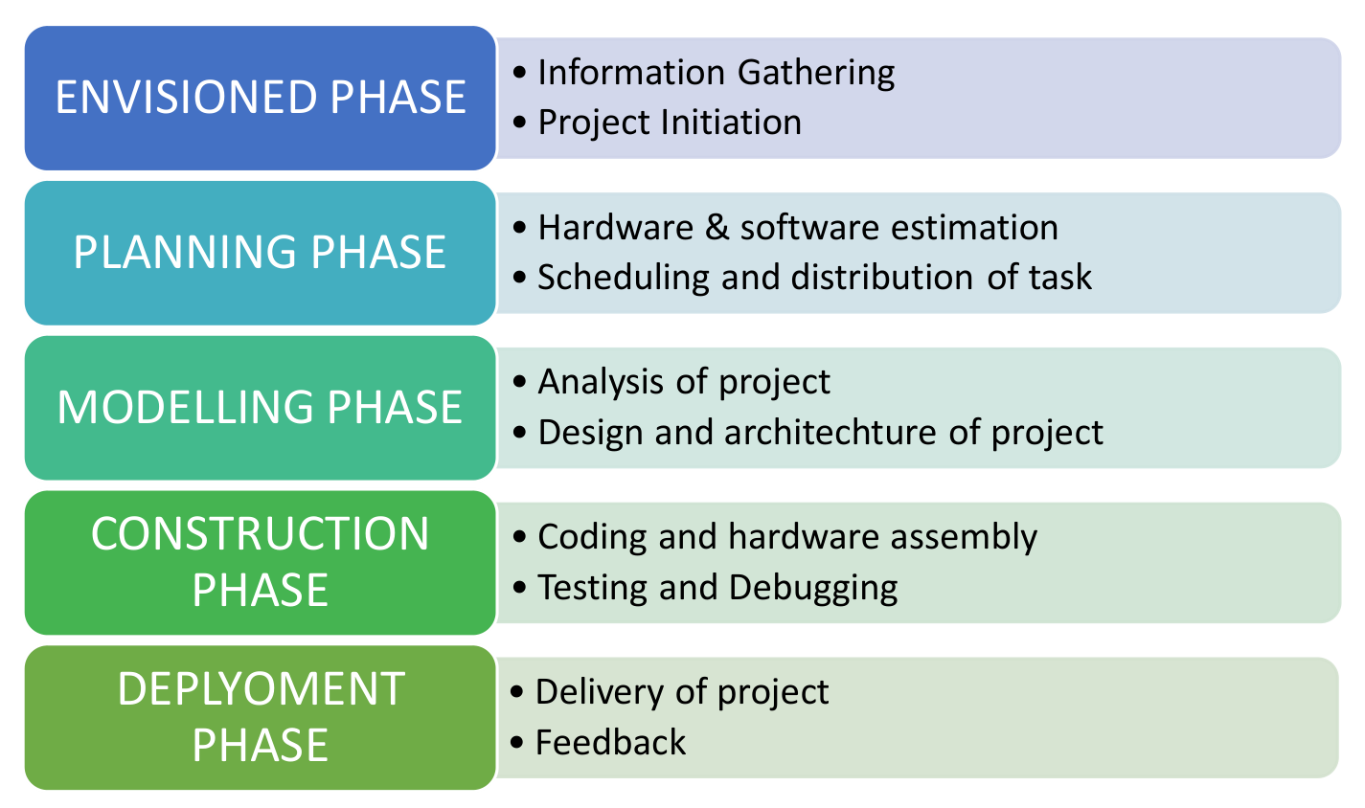
Figure 1.1. Model of phases in project management.

Overview and Benefits
The Gesture Controlled Robot offers several significant benefits:
- Contactless Control: Eliminates physical interaction with controllers
- Natural Interaction: Uses intuitive hand gestures for robot movement
- Improved Safety: Suitable for hazardous and restricted environments
- Low Cost: Built using affordable and widely available components
- Scalability: Can be extended with additional sensors and IoT features
- Educational Value: Enhances understanding of robotics, computer vision, and embedded systems
The project highlights how modern embedded platforms can be combined with vision-based systems to develop intelligent and interactive robotic solutions.

Organization of the Report
The report is organised into the following chapters. Each chapter is unique on its own and is described with necessary theory to comprehend it.
Chapter 2 deals with background survey and review,
Chapter 3 has the description of the theoretical aspects that has been acquired to commence the project work.
Chapter 4 describes the hardware requirements and system working.
Chapter 5 details the software tools, logic and flowcharts used.
Chapter 6 discusses project development, testing, results and analysis.
Chapter 7 concludes the project and highlights limitations and future scope.

Chapter 02: Background Review & Survey

Related Works
Gesture recognition and gesture-controlled robotic systems have been an active research area in the fields of robotics, computer vision, and human–computer interaction. Several researchers have explored different techniques and platforms to achieve intuitive and contactless robot control.
Early gesture-controlled systems primarily relied on sensor-based approaches, such as accelerometers and data gloves, to capture hand movements. While these systems provided reliable gesture detection, they were often expensive, cumbersome, and limited natural hand movement [1]. To overcome these drawbacks, researchers gradually shifted towards vision-based gesture recognition systems using cameras.
Dang and Suh proposed a human-following robot using an infrared camera to detect and track human motion, demonstrating the effectiveness of vision-based approaches in robotic navigation [2]. Their work highlighted how camera-based systems reduce hardware dependency while improving interaction flexibility.
With the advancement of embedded platforms, Raspberry Pi has been widely adopted for robotic applications due to its low cost, compact size, and ability to run Linux-based operating systems. Researchers have successfully implemented gesture-controlled robots using Raspberry Pi integrated with cameras and motor drivers, enabling real-time image processing and robot control [3]. These systems typically use OpenCV for gesture recognition due to its optimized image processing algorithms.
Several studies have utilized OpenCV-based image processing techniques such as skin color segmentation, contour detection, and thresholding to recognize hand gestures. Such techniques offer a balance between computational efficiency and recognition accuracy, making them suitable for Raspberry Pi–based systems [4]. Vision-based gesture control eliminates the need for wearable devices and enhances user comfort.
Recent works also emphasize the application of gesture-controlled robots in hazardous environments, assistive technologies, and automation systems. These robots help reduce human risk by enabling remote and contactless operation [5]. However, challenges such as sensitivity to lighting conditions, background complexity, and gesture ambiguity still remain.
From the literature survey, it is evident that a camera-based gesture-controlled robot using Raspberry Pi and OpenCV provides a cost-effective, flexible, and scalable solution. The reviewed works form the foundation for the proposed system, which aims to achieve reliable gesture recognition with simplified hardware and efficient software implementation.

Chapter 03: Theoretical Aspects

Project Aspects
The Gesture Controlled Robot using Raspberry Pi is designed as an intelligent robotic system that enables natural and touch-free human–robot interaction through hand gestures. Unlike conventional robotic systems that rely on physical input devices such as joysticks, switches, or remote controllers, this project uses camera-based gesture recognition to interpret human intentions and convert them into robotic actions.
At the core of the system is the Raspberry Pi, which functions as the central processing and control unit. The Raspberry Pi continuously receives live video input from a camera positioned to capture the user’s hand movements. These video frames are processed in real time using OpenCV and Python-based image processing algorithms. Through techniques such as image preprocessing, contour extraction, and motion analysis, the system identifies predefined hand gestures.
Each recognized gesture is mapped to a specific robot action. For example, a forward hand movement commands the robot to move forward, while a left or right gesture causes directional turning. Once a gesture is recognized, the Raspberry Pi generates corresponding digital control signals via its GPIO pins. These signals are sent to a motor driver, which amplifies them and drives the DC motors to execute the required movement.
From an IoT perspective, the project demonstrates how sensing, processing, and actuation can be integrated into a single embedded system. The camera acts as the sensing device, the Raspberry Pi performs data processing and decision-making, and the motors act as actuators. Optional network connectivity using Wi-Fi allows remote monitoring, debugging, or future integration with cloud-based services.
The project aspects also emphasize real-time performance and reliability. Since gesture recognition and motor control occur continuously in a loop, the system responds instantly to user actions, providing smooth and intuitive control. Local processing on the Raspberry Pi reduces latency and avoids dependence on external servers, making the system suitable for standalone operation.
Overall, the project highlights the practical application of computer vision, embedded systems, and IoT concepts in robotics. It serves as an effective learning platform for understanding gesture recognition, hardware–software integration, and real-time control, while also offering potential for deployment in areas such as hazardous environment handling, assistive robotics, automation, and education.

Features of IoT
- Intelligence: The system processes visual data and makes decisions based on detected hand gestures.
- Connectivity: Raspberry Pi acts as the central controller, connecting camera input and motor driver output.
- Dynamic Nature: Robot actions change dynamically according to real-time gestures.
- Enormous Scale: The concept can be extended to multiple robots or smart systems.
- Sensing: Camera serves as the primary sensing unit for gesture detection.
- Heterogeneity: Combines hardware (motors, camera) and software (OpenCV, Python).
- Security: Local processing ensures minimal data exposure as no cloud dependency is required.

Advantages of IoT
- Communication: Enables interaction between humans and machines using gestures.
- Automation and Control: Robot movement is automated based on gesture recognition.
- Information: Visual data is analyzed to extract meaningful control signals.
- Monitoring: Continuous monitoring of hand movements through the camera.
- Efficiency: Reduces manual effort and improves operational flexibility.

Disadvantages of IoT
- Compatibility: Integration of different hardware components requires careful configuration.
- Complexity: Image processing algorithms increase system complexity.
- Privacy/Security: Camera-based systems may raise privacy concerns.
- Safety: Incorrect gesture recognition may lead to unintended robot movement.

Application areas of IoT
Gesture controlled robots using IoT can be applied in various fields:
- Healthcare: Assisting patients and doctors through touch-free operation.
- Defense: Handling explosives or surveillance in dangerous areas.
- Industrial Automation: Controlling machines remotely using gestures.
- Home Automation: Smart robots for domestic assistance.
- Education and Research: Learning robotics, AI, and human-machine interaction.

IOT Technologies and Protocols // related to project
- Bluetooth: Can be integrated for short-range communication if needed.
- TCP/IP: Provides reliable data communication over the network for services like SSH and VNC.
- Python: Acts as the core programming technology for gesture processing and hardware control.
- Wi-Fi: Used for remote access, debugging, or monitoring the Raspberry Pi.
- Cellular: Optional for remote operation over long distances.
- OpenCV: Performs real-time camera-based hand gesture recognition using image processing techniques.

Project Layout
The project layout consists of a camera mounted on or near the robot to capture hand gestures. The Raspberry Pi processes video frames using OpenCV algorithms such as background subtraction, contour detection, and convex hull analysis. Based on the recognized gesture, control signals are generated and sent to the motor driver, which drives the DC motors to move the robot accordingly.
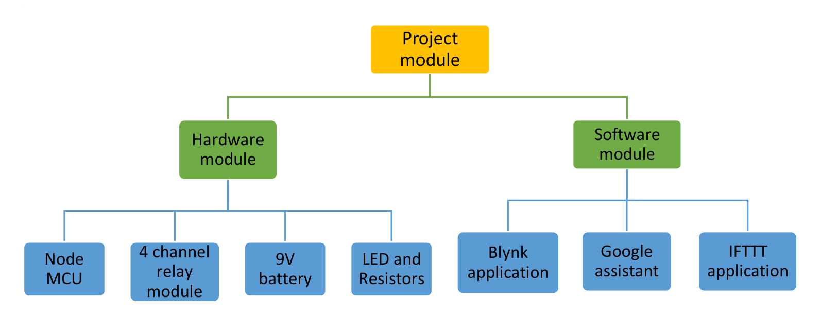
Figure 3.1. Layout of project module

Brief Description
The working of the Gesture Controlled Robot begins when the user performs a predefined hand gesture in front of the camera. These gestures act as control commands and are designed to be simple and easily distinguishable, such as moving the hand forward, backward, left, right, or holding it steady to indicate a stop command. This ensures ease of use and reduces ambiguity during gesture recognition.
The camera continuously captures live video frames of the user’s hand movements and sends this visual data to the Raspberry Pi for processing. The Raspberry Pi runs a Python-based program that uses OpenCV to analyze each frame in real time. Image preprocessing steps such as resizing, noise reduction, grayscale conversion, and thresholding are applied to enhance the quality of the input image and isolate the hand region from the background.
Once the hand region is identified, the system analyzes the shape, contour, and direction of movement to recognize the performed gesture. The recognized gesture is then compared with a set of predefined gesture commands stored in the program. Based on this comparison, the Raspberry Pi determines the appropriate robot movement.
After decision-making, control signals are generated through the GPIO pins of the Raspberry Pi and sent to the motor driver circuit. The motor driver amplifies these low-power signals and supplies sufficient current to the DC motors. As a result, the motors rotate in the required direction, enabling the robot to move forward, backward, turn left or right, or stop.
This entire process operates continuously in a loop, allowing the robot to respond instantly to changes in hand gestures. The real-time execution ensures smooth motion, quick response, and reliable operation. Overall, this brief description highlights how gesture input, image processing, decision logic, and motor control work together to achieve efficient and intuitive control of the robot.

Background Theory
The creation of intelligent and interactive robotic systems has been made possible by the quick development of computer vision and embedded systems. Conventional robot control techniques, like switches, joysticks, or remote controllers, necessitate manual labor and physical contact. Gesture-based control systems have become increasingly important in order to get around these restrictions.
Human hand movements are interpreted as control commands in gesture recognition, a natural and intuitive form of human-machine interaction. Camera-based gesture recognition tracks and detects hand movements in real time using machine learning and image processing techniques. This method offers a contactless control mechanism and does away with the need for wearable sensors.
In this project, real-time video frames are captured and processed via a camera using computer vision techniques. OpenCV, which offers tools for image acquisition, processing, and visualization, is used to analyze the captured images. MediaPipe is used for hand landmark detection in order to improve the accuracy of gesture detection. Reliable gesture recognition is made possible by MediaPipe, which tracks finger positions and identifies important hand points.
The central processing unit is the Raspberry Pi 4, which combines hardware control and vision-based gesture recognition. Control signals are created and transmitted to the motor driver, which operates the DC motors in accordance with the detected gestures. The system's safety and dependability are increased by the incorporation of an ultrasonic sensor to measure distance and identify obstacles.
The suggested gesture-controlled robot is theoretically based on a combination of embedded systems, computer vision, and sensor integration. This method shows how to use natural hand gestures to control robotic systems in an effective, affordable, and user-friendly way.

Chapter 04: Hardware Requirements

Raspberry Pi 4
The Raspberry Pi 4 serves as the brain of the gesture controlled robot. It performs multiple critical tasks such as video acquisition, image processing, gesture recognition, decision-making, and motor control. Unlike conventional microcontrollers, the Raspberry Pi functions as a full-fledged computer, enabling the use of advanced software tools and libraries.
In this project, the Raspberry Pi continuously receives video frames from the camera and processes them using Python-based image processing algorithms. Based on the detected gesture, the Raspberry Pi generates appropriate GPIO signals to control the motor driver. This centralized control architecture simplifies system design and improves reliability.
The Raspberry Pi is also capable of multitasking, allowing simultaneous execution of gesture recognition, motor control, and optional monitoring services. Its compact size and low power consumption make it suitable for mobile robotic applications.

Features
The key features that make Raspberry Pi 4 suitable for this project include:
- High Computational Capability: The quad-core ARM processor enables fast processing of video frames, which is essential for real-time gesture recognition.
- Flexible Memory Options: RAM variants support smooth execution of OpenCV-based image processing programs.
- GPIO Support: The 40-pin GPIO header allows direct interfacing with motor drivers, sensors, and external modules.
- Wireless Connectivity: Built-in Wi-Fi and Bluetooth allow remote login, debugging, and future IoT expansion.
- Peripheral Compatibility: USB ports support camera modules, storage devices, and input peripherals.
- Energy Efficiency: Operates at low power, increasing battery life during mobile operation.
These features collectively enable the Raspberry Pi to handle both computational and control tasks efficiently.

Pin Configuration
The Raspberry Pi’s 40-pin GPIO header plays a crucial role in hardware interfacing. The pins are logically grouped into power, ground, data, and communication categories.
- Power Pins (5V, 3.3V): Supply voltage to sensors and external modules
- Ground Pins: Provide a common reference for all connected components
- GPIO Pins: Used to send digital control signals to the motor driver
- Communication Pins: Support UART, SPI, and I²C protocols
In this project, GPIO pins are configured as outputs to control the motor driver inputs. Careful pin assignment ensures correct motor direction and avoids electrical conflicts. Proper voltage-level matching is essential, as Raspberry Pi GPIO operates at 3.3V logic.

Camera
The camera module acts as the primary sensing device for the system. It captures live video of the user’s hand gestures and provides the raw input required for gesture recognition.
The camera continuously streams video frames to the Raspberry Pi, where image preprocessing and gesture analysis are performed. The accuracy of gesture detection depends on factors such as camera resolution, frame rate, lighting conditions, and background clarity. Proper camera placement and stable mounting significantly improve recognition performance.
Using a camera-based approach offers several advantages:
- Enables natural and contactless control
- Eliminates the need for wearable devices
- Supports flexible and expressive gestures
Thus, the camera is a key component enabling intuitive human–robot interaction.

Sensors
Sensors play a crucial role in enhancing the safety, awareness, and reliability of the Gesture Controlled Robot. While the primary control of the robot is achieved through camera-based hand gesture recognition, sensors provide additional information about the robot’s surrounding environment and operational state. This supplementary data helps the robot make safer movement decisions and prevents accidental collisions.
In the proposed system, sensors act as supporting input devices that complement the vision-based gesture control mechanism. They continuously monitor environmental conditions and provide real-time feedback to the Raspberry Pi, which processes the sensor data along with gesture commands.
One of the most important sensors used in this project is the HC-SR04. This sensor is used for obstacle detection and distance measurement. It works by emitting ultrasonic sound waves and measuring the time taken for the echo to return after reflecting from an object. Using this time delay, the distance between the robot and the obstacle is calculated.
The use of an ultrasonic sensor improves system safety by:
- Detecting obstacles in the robot’s path
- Preventing collisions during movement
- Allowing the robot to stop or change direction if an object is detected nearby
Additional sensors such as accelerometers or gyroscopes can also be integrated to monitor motion, tilt, or orientation of the robot. These sensors are particularly useful for improving stability and ensuring smooth navigation on uneven surfaces.
Overall, sensors enable the robot to interact more intelligently with its environment and enhance the robustness of the gesture-controlled system.

Gesture Sensor
A gesture sensor is used to detect hand movements such as forward, slow and stop gestures. It converts physical gestures into digital signals that are sent to the Raspberry Pi.
Advantages:
- Touchless control
- Fast response time
- Easy interfacing with Raspberry Pi
Gesture sensors enhance user interaction and system efficiency.

Motor Drivers
Motor drivers act as an interface between the Raspberry Pi and the motors. Since Raspberry Pi cannot supply sufficient current to drive motors directly, motor drivers are required.
Functions:
- Amplify control signals
- Protect Raspberry Pi from high current
- Enable direction and speed control
Common motor drivers used are L293D or L298N.

Motors
DC motors are used to move the robot in different directions based on recognized gestures.
Features:
- Forward and reverse rotation
- Speed control through PWM
- Compact and efficient
The motors are connected to wheels to provide mobility to the robot chassis.

Working of the proposed system
The working of the proposed Gesture Controlled Robot using Raspberry Pi is based on a continuous and coordinated interaction between gesture input, image processing, decision making, and motor actuation. The system follows a real-time sense–process–actuate cycle to ensure smooth and responsive robot control.

Step 1: Gesture Input by the User
The operation of the system begins when the user performs predefined hand gestures in front of the camera. These gestures represent control commands such as forward, slow and stop. The gestures are designed to be simple and clearly distinguishable to reduce ambiguity during recognition.

Step 2: Image Capture Using Camera
The camera module continuously captures live video frames of the user’s hand movements. These frames act as raw visual input for the system. The captured video stream is sent directly to the Raspberry Pi, which acts as the central processing unit.
Proper camera placement and adequate lighting conditions help improve gesture detection accuracy.

Step 3: Image Processing and Gesture Recognition
The Raspberry Pi processes each captured video frame using Python and OpenCV. Several image processing steps are applied to extract meaningful information from the video input:
- Conversion of the image to grayscale
- Noise reduction and smoothing
- Thresholding to separate the hand from the background
- Contour detection to identify the hand shape
- Analysis of hand movement direction and shape
Based on these processed features, the system recognizes the performed hand gesture by comparing it with predefined gesture patterns stored in the program.

Step 4: Decision Making and Control Signal Generation
Once the gesture is successfully recognized, the Raspberry Pi performs decision making by mapping the gesture to a specific robot action:
- Forward gesture → Robot moves forward
- Slow gesture → Robot moves forward but slower
- Stop gesture → Robot stops
Corresponding digital control signals are then generated through the Raspberry Pi GPIO pins.

Step 5: Motor Driver Operation
The generated control signals are sent to the L293D motor driver. The motor driver plays a critical role by:
- Amplifying low-power GPIO signals
- Providing sufficient current to drive the motors
- Controlling the direction of motor rotation
- Protecting the Raspberry Pi from high current and back EMF
This ensures safe and reliable motor operation.

Step 6: Motor Actuation and Robot Movement
The DC motors connected to the motor driver rotate according to the received signals:
- Both motors rotate forward → Robot moves forward
The wheels attached to the motors enable smooth movement of the robot across the surface.

Step 7: Obstacle Detection and Safety (Optional)
An ultrasonic sensor such as the HC-SR04 can be used to detect obstacles in front of the robot. If an obstacle is detected within a predefined distance, the Raspberry Pi can override gesture commands and stop the robot to prevent collisions, improving operational safety.

Step 8: Continuous Real-Time Operation
The entire process runs continuously in a loop. As long as the camera captures gestures, the Raspberry Pi keeps processing video frames, recognizing gestures, and updating motor actions in real time. This ensures:
- Fast response
- Smooth robot movement
- Reliable and intuitive control

Block Diagram of the system

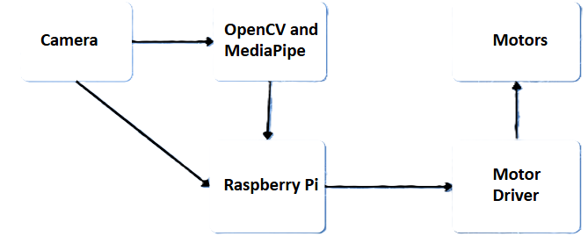
Figure 4.1. Block diagram

Circuit Diagram

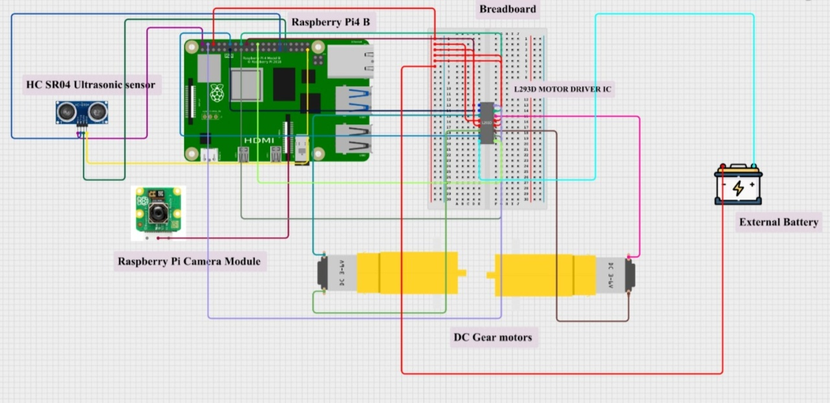
Figure 4.2. Circuit diagram

Working

The gesture controlled robot operates by integrating image capture, gesture recognition, signal processing, and motor control. The entire system works in a sequential and continuous manner to ensure real-time response to user gestures.
- GestureInput by the User
The user performs predefined hand gestures such as moving the hand forward, slow or stopping. These gestures act as control commands for the robot.
- Image Capture Using Camera
The Raspberry Pi camera module continuously captures live video frames of the user’s hand movements. The camera acts as the primary input device and provides real-time visual data to the Raspberry Pi.
- Gesture Detection and Processing
The captured video frames are processed inside the Raspberry Pi using OpenCV-based image processing techniques.
  - The hand region is detected from the video frame
  - Image preprocessing such as grayscale conversion, thresholding, and contour detection is applied
  - The shape, direction, and movement of the hand are analyzed
  - Based on the detected pattern, the corresponding gesture is identified
- DecisionMaking by Raspberry Pi
Once the gesture is recognized, the Raspberry Pi compares it with predefined commands stored in the program.
  - Forward gesture → Move robot forward
  - Slow gesture → Move robot forward but in a slower motion
  - Stop gesture → Stop robot movement
The Raspberry Pi then generates appropriate control signals for the motor driver.
- Motor Driver Operation
The motor driver (L293D/L298N) receives low-power control signals from the Raspberry Pi GPIO pins.
  - It amplifies the signals
  - Provides sufficient current to the motors
  - Controls the direction of motor rotation
The motor driver also protects the Raspberry Pi from back EMF and high current drawn by the motors.
- Movement of Motors and Robot
The DC motors rotate according to the signals received from the motor driver.
  - Clockwise rotation moves the robot forward
  - Anti-clockwise rotation moves it backward
  - Selective motor activation helps in turning left or right
The wheels attached to the motors enable smooth movement of the robot on the surface.
- Continuous Real-Time Operation
The entire process runs continuously in a loop. As long as the camera captures gestures, the Raspberry Pi keeps processing them and updates the motor actions in real time. This ensures smooth and responsive control of the robot.

Components Required
Table 4.1. Component listing.
Sl. No. | Component and Specification | Quantity
 | Raspberry Pi 4- Central controller | 1
 | Camera Module- Gesture detection | 1
 | Motor Driver(L293D)- Motor control | 1
 | DC Motors- Robot movement | 2
 | Wheels- Mobility | 2
 | Power supply- System power | 1
 | HC SR04 Ultrasonic Sensor- Obstacle Detection | 1

Chapter 05: Software Requirements

Thonny IDE/ VS code/ Python
The software part of the project is developed using Python programming language on the Raspberry Pi OS platform. Python is chosen due to its simplicity, readability, and strong support for hardware control and image processing.
Python 3 is used as the main programming language.
Thonny IDE is used for writing, editing, and testing Python programs on Raspberry Pi.
OpenCV (cv2) library is used for camera access and image processing.
MediaPipe is used for real-time hand gesture detection.
RPi.GPIO library is used to control GPIO pins for motors and sensors.
time and math libraries are used for delays and calculations.
The program integrates gesture recognition with motor control and obstacle detection.

Logic and Flowchart
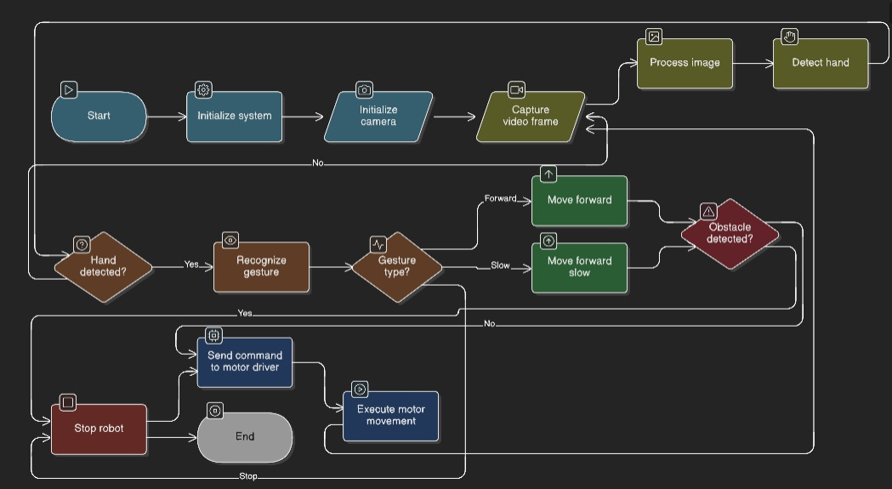

Figure 5.1. Flow chart

Chapter 06: Project development & Testing Aspects

Hardware Integration
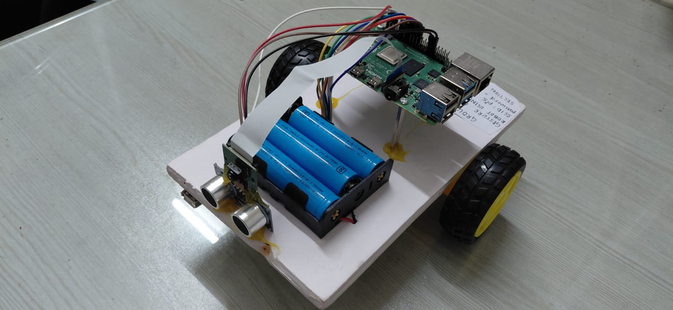
Figure 6.1. Hardware integration

The hardware components are assembled and interfaced with the Raspberry Pi.
Raspberry Pi 4 acts as the main controller.
Camera module is connected through the CSI port.
DC motors are connected using the L293D motor driver.
Ultrasonic sensor (HC-SR04) is connected to GPIO pins for obstacle detection.
External battery is used to power motors safely.
Common ground is maintained between Raspberry Pi and motor driver.
All components are tested individually before full integration.

Software Set-up
The gesture controlled robot uses a Raspberry Pi as the main controller. The Raspberry Pi OS was installed on a microSD card and configured. Required libraries such as Python, OpenCV, and GPIO control libraries were installed to support image processing and motor control.
The program is written in Python. The Raspberry Pi camera is used to capture real-time hand gestures. The Python script processes the video frames using OpenCV, detects hand gestures, and converts them into control commands. These commands are then sent to the motor driver module to control the movement of the robot (forward, slow, and stop).
The Raspberry Pi was accessed remotely using RealVNC Viewer, which allowed graphical access to the Raspberry Pi desktop from a laptop. Through RealVNC, the program files were opened, edited, and executed without the need for a dedicated monitor or keyboard connected to the Raspberry Pi.
The program was executed using the terminal in the RealVNC desktop environment with the command:
python3 gesture_con_robot.py

Testing
The project is tested in multiple stages:
Camera Testing: Verified using camera preview commands.
Motor Testing: Motors tested using simple GPIO test programs.
Ultrasonic Sensor Testing: Distance measurement verified using test code.
Gesture Testing: Hand gestures tested under different lighting conditions.
Integrated Testing: Full system tested with gesture control and obstacle detection.
Each module is tested independently before final integration.

Results and Discussions

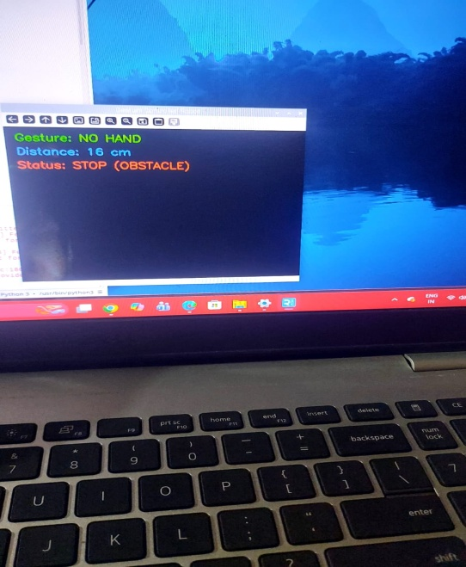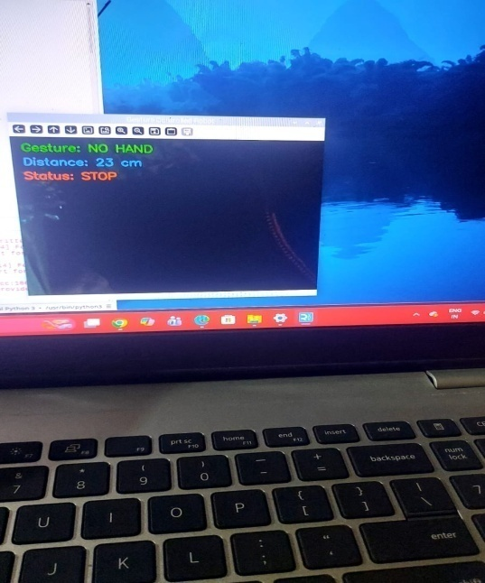
Figure 6.1screenshot ofstop when obstacle is detectedor when no hand

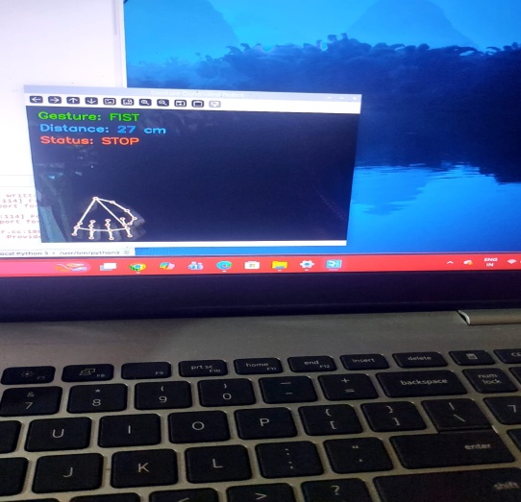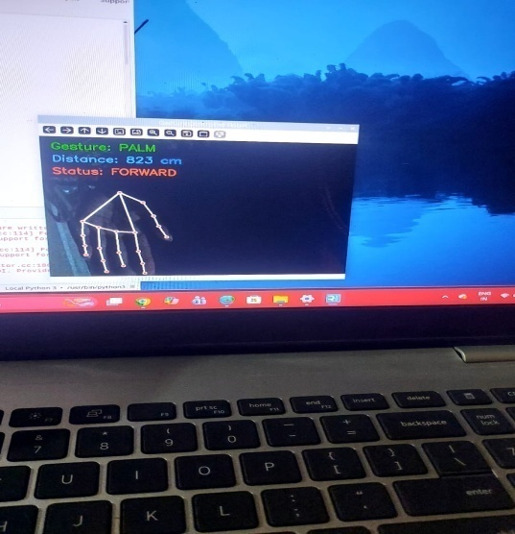

Figure 6.2screenshots of gesture detection:fist(stop)and palm (forward)

The gesture-controlled robot successfully responds to hand gestures in real time.
The robot moves forward and stops based on gestures.
Obstacle detection improves safety by stopping the robot automatically.
The system works in standalone mode and starts automatically on power ON.
Performance depends on lighting conditions and camera placement.
The results show that the proposed system is reliable and effective for gesture-based control.

Chapter 07: Mathematical Analysis Of the System

1. Image Capture and Processing
The camera connected to the Raspberry Pi Foundation captures live video frames with a resolution of:
640 × 480 pixels
Each frame can be represented mathematically as:
I(x, y)
Where:
- x, y → Pixel position in the image
- I(x, y) → Color intensity value at that pixel
The image is horizontally flipped to create a mirror effect so that user hand movements appear natural.

2. Hand Detection using MediaPipe
The system uses MediaPipe to detect the hand.
MediaPipe identifies 21 hand landmarks.
Each landmark has 3D coordinates:
(x, y, z)
Where:
- x, y → Normalized image coordinates (range 0 to 1)
- z → Depth value (distance from camera)
Processing pipeline:
Image → Hand Landmarks → Finger Position Analysis
Only detections with confidence > 0.7 are considered valid.

3. Finger Counting Logic
The gesture is determined by checking whether fingers are open or closed.
For each finger (index, middle, ring, little), the system compares:
y_tip and y_base
If:
y_tip > y_base → Finger is OPEN
This works because in digital images:
- The y-axis increases downward
- A larger y-value means the point is lower in the image
Total number of open fingers:
F = Number of open fingers

4. Gesture Classification
Robot speed depends on the number of detected open fingers.
Open Fingers (F) | Mode | Speed
F ≥ 4 | FAST | 70%
F = 3 | SLOW | 40%
F < 3 | STOP | 0%
Mathematically:
Speed = 70% if F ≥ 4
Speed = 40% if F = 3
Speed = 0% if F < 3
This speed controls the motor through PWM.

5. Ultrasonic Distance Measurement
The ultrasonic sensor calculates distance using echo time.
Let:
- t = Echo return time
- v = Speed of sound = 34300 cm/s
Distance formula:
D = (v × t) / 2
Division by 2 is required because the sound travels to the object and back.
If:
D < 20 cm → Robot stops automatically
This prevents collision.

6. PWM (Pulse Width Modulation) Motor Control
Motor speed is controlled using PWM.
Duty cycle formula:
Duty Cycle = (T_ON / T_TOTAL) × 100
Mode | Duty Cycle
FAST | 70%
SLOW | 40%
STOP | 0%
A higher duty cycle gives higher average voltage and increases motor speed.

7. Overall System Working
Main control flow:
Camera → Hand Detection → Finger Counting → Speed Decision → Motor Control
Parallel safety system:
Ultrasonic Sensor → Distance Calculation → Automatic Stop

Chapter 08: Conclusion &Future Scope

8.1.Conclusion
The Gesture Controlled Robot using Raspberry Pi project has been successfully designed, developed, and tested to demonstrate an intuitive and contactless method of robotic control. The system replaces conventional control mechanisms such as remote controllers and joysticks with hand gesture-based commands, thereby improving human–robot interaction and usability.
In this project, a camera-based gesture recognition approach was implemented using OpenCV and Python. Hand gestures captured by the camera are processed in real time by the Raspberry Pi, which identifies predefined gesture patterns and maps them to corresponding robot movements. The integration of a motor driver ensures safe and reliable operation of the DC motors, while the inclusion of an ultrasonic sensor enhances the safety of the system by detecting obstacles during movement.
The project effectively integrates concepts from computer vision, embedded systems, robotics, and Internet of Things (IoT). The Raspberry Pi proves to be a powerful and flexible platform capable of handling real-time image processing and motor control simultaneously. The developed robot responds accurately to user gestures under controlled conditions and demonstrates smooth and reliable motion.
Overall, the project achieves its stated objectives and validates that gesture-based control is a practical, low-cost, and efficient solution for robotic applications. It also serves as a strong educational platform for understanding hardware–software integration and real-time system design.

8.2.Limitations
Although the proposed system performs satisfactorily, certain limitations were identified during implementation and testing:
- The accuracy of gesture recognition is sensitive to lighting conditions, shadows, and background complexity.
- The system relies on predefined static gestures, limiting the range of commands that can be executed.
- Complex or rapid hand movements may result in misinterpretation or delay in recognition.
- The processing capability of the Raspberry Pi places constraints on handling very high-resolution video or advanced algorithms simultaneously.
- The robot is primarily suitable for indoor and controlled environments and may not perform reliably outdoors.
- The absence of learning-based models restricts adaptability to different users’ gesture styles.
These limitations indicate areas where further improvements and optimizations can be made.

8.3.Further Enhancement and Future Scope
The gesture controlled robot developed in this project provides a solid foundation for future enhancements and advanced applications. Several improvements can be considered to extend the system’s capabilities:
- Advanced Gesture Recognition Techniques
Machine learning or deep learning-based models can be integrated to improve gesture recognition accuracy and robustness. This would allow the system to recognize dynamic and complex gestures with higher precision.
- User Adaptability
Training the system to adapt to different users’ hand sizes, speeds, and gesture styles can improve usability and personalization.
- Multimodal Control
Combining gesture control with voice commands or mobile application control can provide a more flexible and reliable interaction mechanism.
- Wireless and Cloud Integration
IoT cloud platforms can be used for remote monitoring, data logging, and real-time control over the internet, enabling large-scale deployment.
- Enhanced Navigation and Autonomy
Additional sensors such as IR sensors, GPS modules, and gyroscopes can be added to improve navigation, obstacle avoidance, and autonomous behavior.
- Real-World Applications
The system can be deployed in hazardous environments, healthcare assistance, industrial automation, defense applications, and smart homes, where touch-free control is essential.
With these enhancements, the proposed system can evolve into a more intelligent, adaptive, and autonomous robotic platform suitable for real-world applications and advanced research.

References
[1] Q. K. Dang and Y. S. Suh, “Human-following robot using infrared camera,” in Proceedings of the 11th International Conference on Control, Automation and Systems, Gyeonggi-do, Korea (South), IEEE, Oct. 2011, pp. 1054–1058.
[2] S. Mitra and T. Acharya, “Gesture recognition: A survey,” IEEE Transactions on Systems, Man, and Cybernetics, Part C (Applications and Reviews), vol. 37, no. 3, pp. 311–324, May 2007.
[3] S. S. Rautaray and A. Agrawal, “Vision based hand gesture recognition for human computer interaction: A survey,” Artificial Intelligence Review, vol. 43, no. 1, pp. 1–54, Jan. 2015.
[4] G. Bradski and A. Kaehler, Learning OpenCV: Computer Vision with the OpenCV Library, 1st ed., Sebastopol, CA, USA: O’Reilly Media, 2008.
[5] A. Sharma, R. Singh, and P. Kumar, “Hand gesture controlled robotic system using Raspberry Pi,” International Journal of Engineering Research & Technology (IJERT), vol. 9, no. 4, pp. 227–231, Apr. 2020.
[6] Raspberry Pi Foundation, “Raspberry Pi Documentation,” [Online]. Available: https://www.raspberrypi.com/documentation/. Accessed: Dec. 10, 2025.
[7] OpenCV Team, “OpenCV Documentation,” [Online]. Available: https://docs.opencv.org/. Accessed: Dec. 12, 2025.

Appendix 01

A01.1. Code Listing
Function Name | Purpose
initialize_gpio() | Configures Raspberry Pi GPIO pins for motor driver and sensor
move_forward() | Moves the robot forward
stop_robot() | Stops all motor movement
detect_gesture(frame) | Detects hand gesture from camera frame
process_frame(frame) | Preprocesses camera frame for gesture detection
measure_distance() | Measures distance using ultrasonic sensor
cleanup() | Resets GPIO pins on program exit

A01.2. Main Code
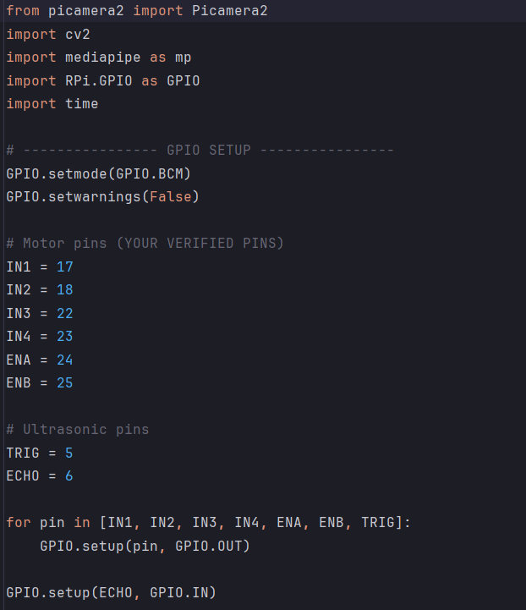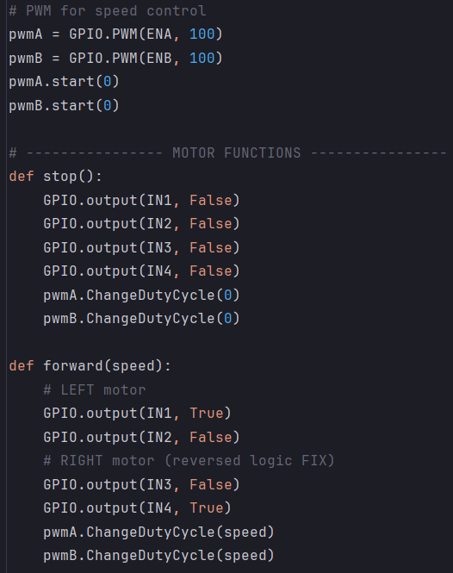
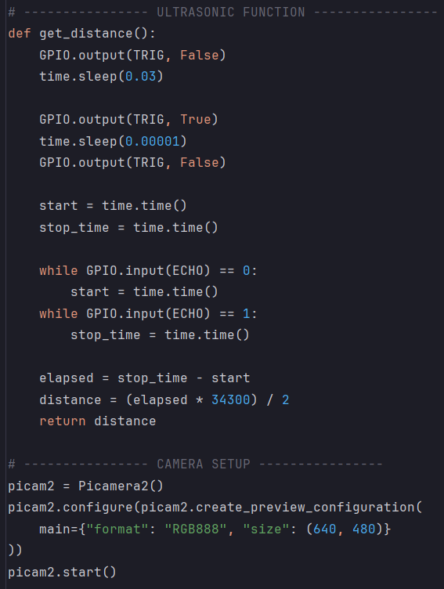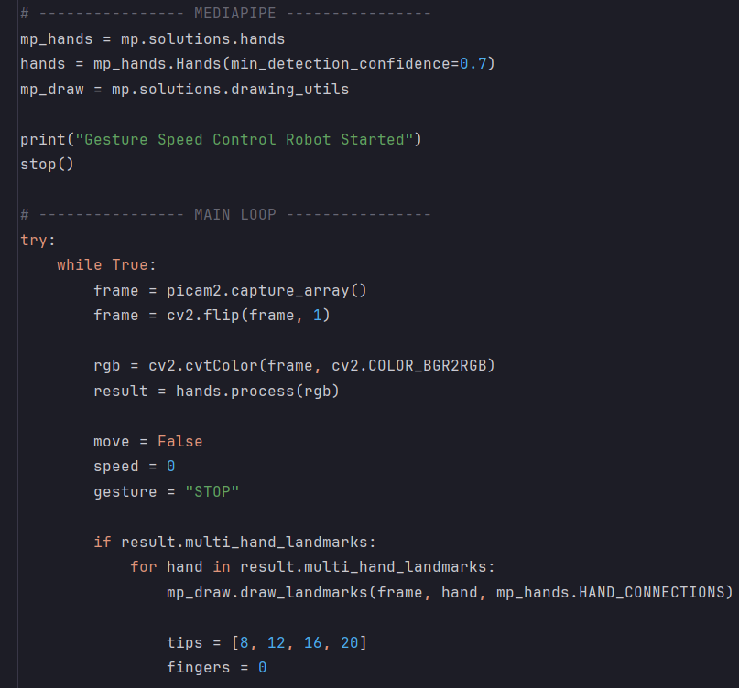
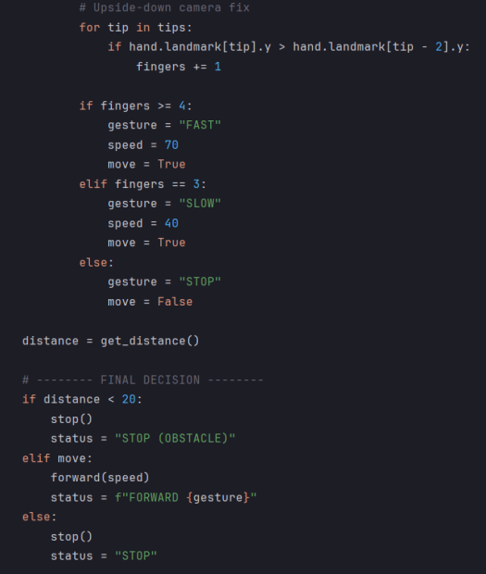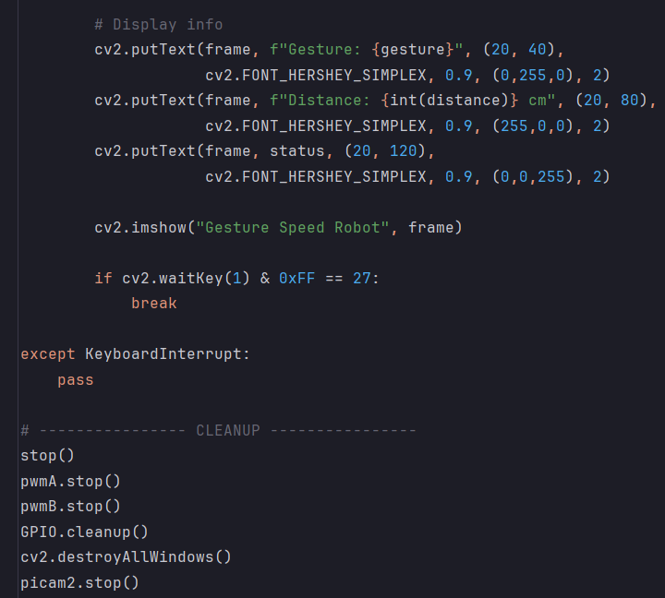
Figure 8.1. main code

A01.3. Libraries
Library Name | Purpose
Python 3 | Core programming language
OpenCV (cv2) | Image capture and processing
MediaPipe | Hand landmark detection and gesture recognition
RPi.GPIO | GPIO pin control for motors and sensors
time | Delay and timing functions
math | Mathematical calculations

Appendix 02

A02.1. Project Proposal Form
The project proposal form was prepared and duly signed from our Faculty-in-Charge Dr.Shaktijeet Mahapatra and Dr. Bhanja Kishor Swain. The same is attached at the last of this report.

A02.2. Project Management
# | Component |  | Individual Contributions in % |  |  |  | Total
 |  | Shreya | Payal | Tanisha | Abhipsa | Ipsita
1. | Planning | 20 | 20 | 20 | 20 | 20 | 100
2. | Background Research and Analysis | 20 | 20 | 20 | 20 | 20 | 100
3. | Hardware design | 20 | 20 | 20 | 20 | 20 | 100
4. | Software design | 20 | 20 | 20 | 20 | 20 | 100
5. | Testing | 20 | 20 | 20 | 20 | 20 | 100
6. | Final Assembling | 20 | 20 | 20 | 20 | 20 | 100
7. | Project report writing | 20 | 20 | 20 | 20 | 20 | 100
8. | Presentation | 20 | 20 | 20 | 20 | 20 | 100
9. | Logistics | 20 | 20 | 20 | 20 | 20 | 100

A02.3. Bill of Material
Table 1. Component listing.
# | Component | Specification | Unit Cost | Quantity | Total
 | Raspberry Pi 4b | single board computer controller |  | 1 | 5099
 | HC SR04 Ultrasonic Sensor | ultrasonic distance sensor |  | 1 | 59
 | Motor Driver L293D | Dual H-bridge motor driver IC |  | 1 | 109
 | DC Gear Motor | DC motor for movement |  | 2 | 110
 | Robot Wheel | Wheel for motor based mobility |  | 2 | 50
 | Power supply | Provides required system voltage |  | 1 | 739
 | SD Card Reader | Storage for OS and data |  | 1 | 469
Grand Total |  |  |  |  | 6635

Appendix 03

A03.1. Data Sheets

1. Raspberry Pi 4 Model B
- Processor: Quad-core ARM Cortex-A72 (64-bit)
- Clock Speed: 1.5 GHz
- RAM: 2 GB / 4 GB / 8 GB (commonly 4 GB used)
- Operating Voltage: 5 V DC
- Recommended Current: 3 A
- GPIO Logic Level: 3.3 V
- GPIO Pins: 40-pin header
- Connectivity: Wi-Fi (2.4 GHz & 5 GHz), Bluetooth 5.0
- Camera Interface: CSI port
- USB Ports: 2 × USB 3.0, 2 × USB 2.0
- Operating System: Raspberry Pi OS (Linux)

2. HC-SR04 Ultrasonic Sensor
- Operating Voltage: 5 V DC
- Operating Current: 15 mA
- Measuring Range: 2 cm – 400 cm
- Measuring Angle: 15°
- Accuracy: ±3 mm
- Trigger Input: 10 µs TTL pulse
- Echo Output: TTL level
- Operating Frequency: 40 kHz
- Function: Distance measurement and obstacle detection

3. Motor Driver L293D
- Motor Supply Voltage (Vcc2): 4.5 V – 36 V
- Logic Supply Voltage (Vcc1): 5 V
- Output Current: 600 mA per channel
- Peak Output Current: 1.2 A
- Number of Motors Controlled: 2 DC motors
- Control Type: Dual H-Bridge
- Logic Compatibility: TTL
- Protection: Built-in flyback diodes
- Function: Motor direction and speed control

4. DC Gear Motor
- Rated Voltage: 6 V – 12 V DC
- Operating Current: 200–300 mA
- No-Load Speed: ~150 RPM
- Torque: High torque (geared)
- Direction: Clockwise & Anti-clockwise
- Shaft Type: Single shaft
- Application: Robot movement

5. Robot Wheel
- Diameter: ~65 mm
- Material: Plastic with rubber grip
- Shaft Compatibility: DC motor shaft
- Load Capacity: Light-weight robotic applications
- Function: Provides mobility to robot

6. Power Supply
- Output Voltage:
  - 5 V DC (Raspberry Pi)
  - 6–12 V DC (Motors)
- Current Rating: Up to 3 A
- Type: Adapter / Rechargeable battery
- Protection: Over-current and short-circuit protection
- Function: Supplies power to entire system

7. SD Card Reader / SD Card
- Storage Capacity: 16 GB / 32 GB
- Speed Class: Class 10
- Interface: Micro-SD
- File System: FAT32
- Function: OS installation and data storage for Raspberry Pi

